Rise of Dictators

Complete the chart below using the reading provided. Identify which political system was used and 3 characteristics of each. In the bottom row, explain how each gained and kept power.

Soviet Union  Joseph Stalin  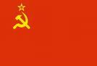 |  | Italy  Benito Mussolini  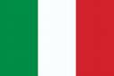 | Germany  Adolf Hitler  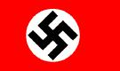 |  |  | Japan  Hideki Tojo  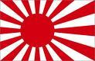
Fascism, militarism, Nazism or Communism  1.  2.  3. |  | Fascism, militarism, Nazism or Communism  1.  2.  3. | Fascism, militarism, Nazism or Communism  1.  2.  3. |  |  | Fascism, militarism, Nazism or Communism  1.  2.  3.
How they gained and kept power

